
AIR UNIVERSITY
DEPARTMENT OF MECHATRONICS ENGINEERING SEMESTER: Spring – 2026

Computer programming
CE-112

Class Task

Instructor: Umer Farooq

Date: 14 March, 2026

Name: Saud Ur Rehman
Name in ASCII( HEX): 115 97 117 100 32 117 114 32 114 101 104 109 97 110

Rollno: 2501496
Rollno: (in 4bit Hex)0010 0101 0000 0001 0100 1001 0110

Task | Write Status | Remarks
1. | Complete | Coding may take some time to understand but it fun
2.
3.


AIR UNIVERSITY
DEPARTMENT OF MECHATRONICS ENGINEERING SEMESTER: SPRING 2026
Computer Programming CE-112

Assignment-1
Instructor: Umer Farooq Due Date: 7th May 2026 Soft Copy Time :10:00 PM

Cover Page must be filled as per attached.
Name Saud Ur Rehman Name in ASCII (HEX) 115-97-117-100 Roll no 2501496 Roll no: in 4bit Hex 0001 0100 1001 0110 Nameimg Convention of file should be done as descibed in file format to avoid marks deduction
Course_Serial_ Section No_2501496 Name Saud Ur Rehman A3_07_MaY 1

Questio n No | Write Status(Complete/Not complete and issue that you faced (compulsory Question will be checked on bases of this index) | Remarks  Must be filled for every question
1 | Completed | No Issue
2 | Completed | No Issue
3 | Completed | No Issue
4 | Completed | No Issue
5 | Completed | No Issue
N | Add more Rows when required

according to number of questions
attempted

Total Questions are 5 covering your Project, add all the following For all questions you must do the following procedures
- Make block diagram for all function inputs & outputs
- Make Flowchart for code
- Write code in C++
- Comment code
- Show all calculation and register setting in binary mark a square boundary around the register setting and show which register are you using.
- Copying other code will get you 0 marks
- Screen Shots of Code along with simulations are to be attached

All programs should be made using functions

Design the loop below and show the calculations. Also, explain everything in a video and upload

- Write and test the following function that returns through its reference parameters both
the maximum and the minimum values stored in an array: void getExtremes(float& min, float& max, float a[], int n);

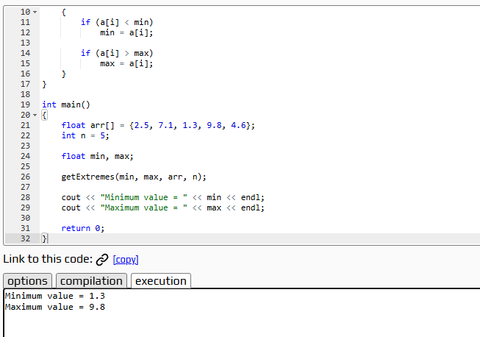

- Write and test the following function:
double stdev(double x[], int n);

The function returns the standard deviation of a data set of n numbers x0… xn–1
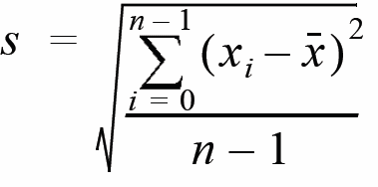

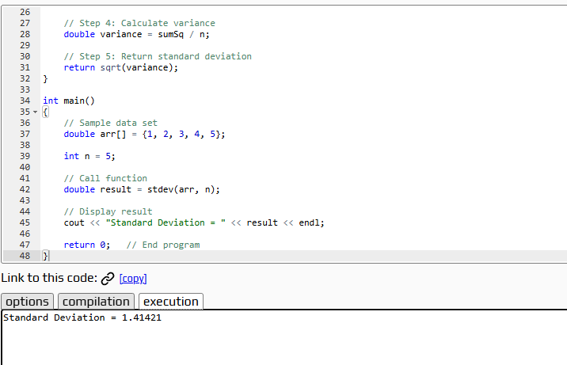

- Write a and test a program to calculate

Write a program to multiply two 3x3 matrices .Make with function that can pass array to each function.
GetValue(PassArray) ComputeAxA(PassArray) PrintArray(PassArray)

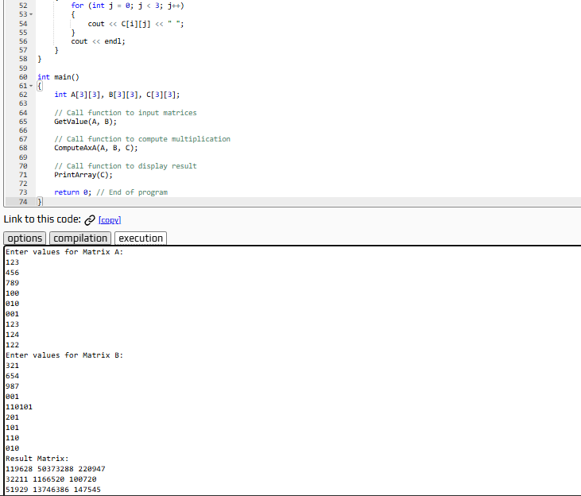

- Write a program that takes a string from the user. The program then calculates the
  - Total number of Characters
  - Total number of Spaces
  - Total number of Tabs
  - Total number of Lines
  - ​

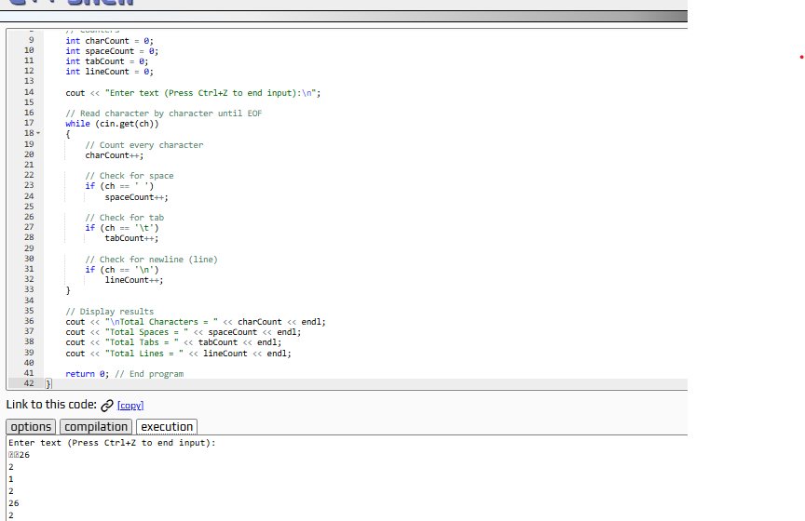

- Write a program to calculate mean, median and mode of an array using funcation

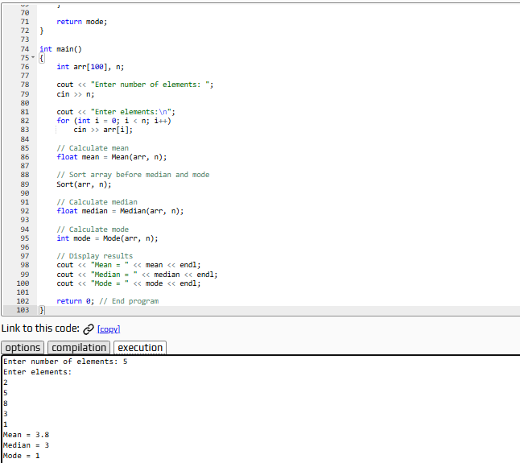

Hand written programme Codes




